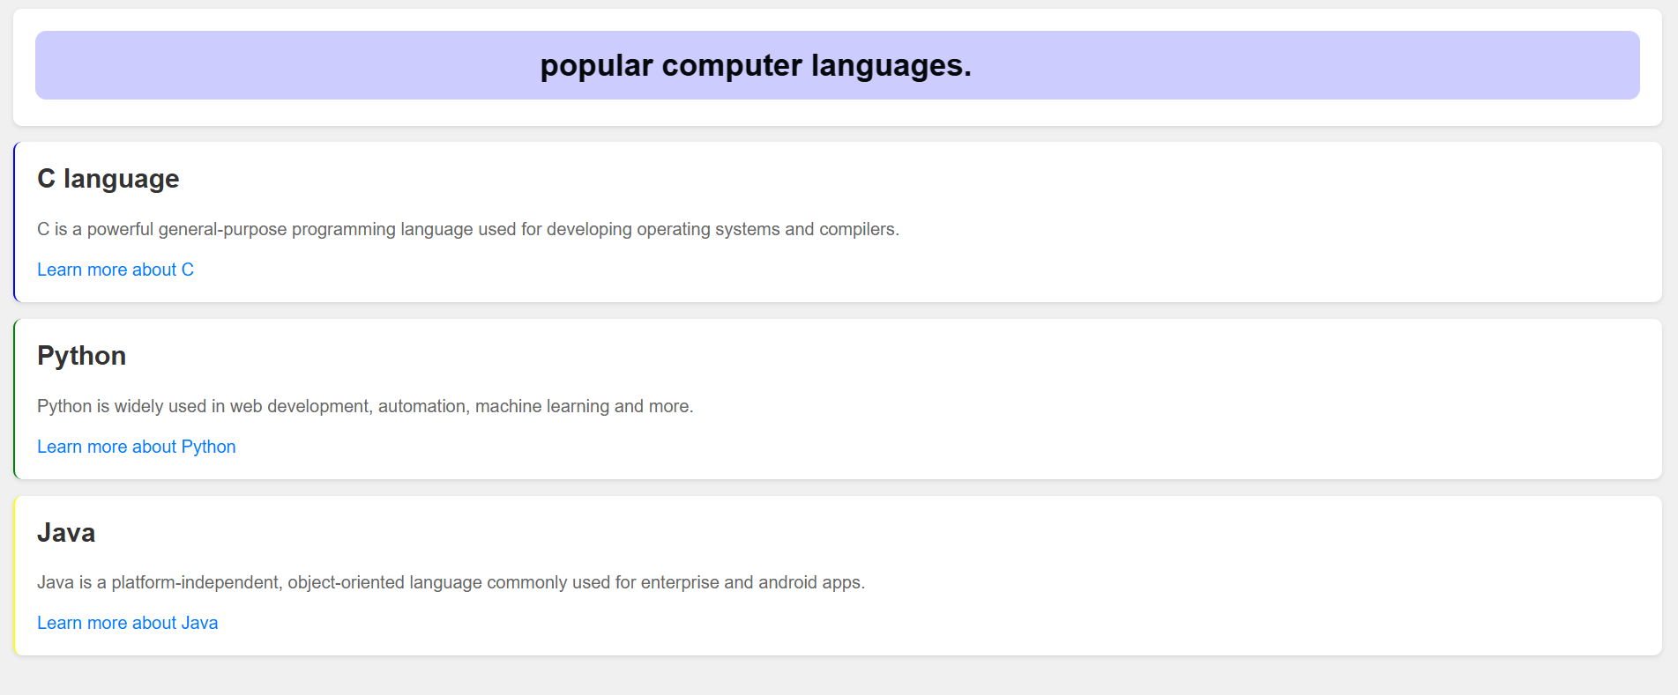
Practical 5 HTML
<!DOCTYPE html>
<html lang="en">
<head>
<meta charset="UTF-8">
<meta name="viewport" content="width=device-width, initial-scale=1.0">
<title>Programming languages</title>
<style>
body {
font-family: Arial, sans-serif;
background-color: #f0f0f0;
margin: 20px;
}

.language-section {
background-color: #ffffff;
border-radius: 8px;
padding: 20px;
margin-bottom: 15px;
box-shadow: 0 2px 4px rgba(0,0,0,0.1);
}

.language-section h2 {
color: #333;
margin-top: 0;
}

.language-section p {
color: #666;
line-height: 1.5;
}

.learn-more {
color: #007bff;
text-decoration: none;
}

.learn-more:hover {
text-decoration: underline;
}
</style>
</head>
<body>

<div class="language-section">
<marquee behaviour="scroll" direction="left" scrollamount="10" style="background-color: #ccff; padding: 15px; border-radius: 10px; color: #04080b; font-size: 28px; font-weight: bold;">
popular computer languages.
</marquee>
</div>

<div class="language-section" style="border-left: 2px solid blue;">
<h2>C language</h2>
<p>C is a powerful general-purpose programming language used for developing operating systems and compilers.</p>
<a href="#" class="learn-more">Learn more about C</a>
</div>

<div class="language-section" style="border-left: 2px solid green;">
<h2>Python</h2>
<p>Python is widely used in web development, automation, machine learning and more.</p>
<a href="#" class="learn-more">Learn more about Python</a>
</div>

<div class="language-section" style="border-left: 2px solid yellow;">
<h2>Java</h2>
<p>Java is a platform-independent, object-oriented language commonly used for enterprise and android apps.</p>
<a href="#" class="learn-more">Learn more about Java</a>
</div>

</body>
</html>

